**Protecting your voice in dangerous times**

*Webinar to unpack ways women+ can protect themselves online*

Doxing. Stalking. Deepfakes. Cancel culture. These are just some of the ways that women are experiencing gender based violence in online spaces.

Quote This Woman+, an intersectional feminist organisation working in the media space, is helping women+ journalists, and those quoted in the media and online, to develop practical skills to protect their voices online.

“When we see women+ being bullied and shouted down on the global stage, it can make us think twice about speaking up and speaking out. But now, more than ever, it’s absolutely critical that women+ feel safe to use their voices in the media and social media space,” says the organisation’s executive director Kath Magrobi.

“According to UN Women research spanning five countries in Sub-Saharan Africa, [more than one quarter of women have experienced violence online](https://www.apc.org/en/pubs/alternate-realities-alternate-internets-african-feminist-research-feminist-internet). That’s an unbelievably large proportion. It’s hardly surprising then that more and more women+ here in Africa are feeling scared to say things that run counter to the new wave of conservative ideologies. UN Women has raised valid concerns about digital abuse, trolling, stalking, and other forms of technology-facilitated violence against women. And we agree with their findings that technology is being weaponised in new ways that reinforce inequality against women and girls. Women+ must be equipped to protect themselves.”

Magrobi says that in 2025, QW+ has picked up a trend of African women+ voices retreating from the public sphere, and that this has been mirrored on the global stage in the context of recent online hate towards people like the Bishop of Washington, Mariann Edgar Budde at a USA national prayer service at the Episcopal Washington National Cathedral on January 21.

“UN Women reports that [technology-facilitated gender-based violence is on the up](https://www.unwomen.org/sites/default/files/2024-10/a-79-500-sg-report-ending-violence-against-women-and-girls-2024-infographic-and-recommendations-en.pdf), posing serious threats of danger to women and girls everywhere. There is a growing backlash against women’s rights, expedited by AI, and a deepening of the ‘manosphere’, which UN Women describes as an ecosystem of misogynistic content that is seeping into mainstream culture, shaping public attitudes towards women, and fuelling violence,” says Magrobi.

Other forms of abuse that women and girls face include cyberbullying, hate speech, sexual exploitation, defamation, intimate image-sharing, sextortion and revenge porn.

To respond to this in a pragmatic way, QW+ is hosting award-winning speakers - Paula Fray (journalist, editor, trainer and media manager), Athandiwe Saba (tech/AI expert, media investigative data journalist), and Asanda Ngoasheng (strategic communications consultant, political analyst and diversity facilitator) - to unpack valuable skills to prepare those involved in the QW+ current fellowship, QW+ experts, and their media allies. “Quote This Woman+ will not waver in its fight to equip women+ thought leaders, experts, and activists with the tools they need to keep speaking up in challenging environments,” says Magrobi.

“Investing an hour of time in this webinar will help women, LGBTQ+ people, and otherwise overlooked experts feel more confident to speak up in ways that challenge dominant narratives. And we invite women+ to bring their daughters and gender-diverse children along too. The question is, can any woman+ using social media afford not to be there?” asks Magrobi.

The webinar is free and takes place at 7pm on March 22. To register, scan this QR code below or email [hello@quotethiswoman.org.za](mailto:hello@quotethiswoman.org.za).

Any queries: Kath Magrobi, Director of Quote This Woman+ kath@quotethiswoman.org.za

Ends

Note: QW+ is an intersectional feminist organisation that aims to transform gender representation in the media landscape by promoting women+ voices and narratives that reflect African demographics and perspectives. The + in our name means we are inclusive of all people whose voices are unheard in mainstream media.

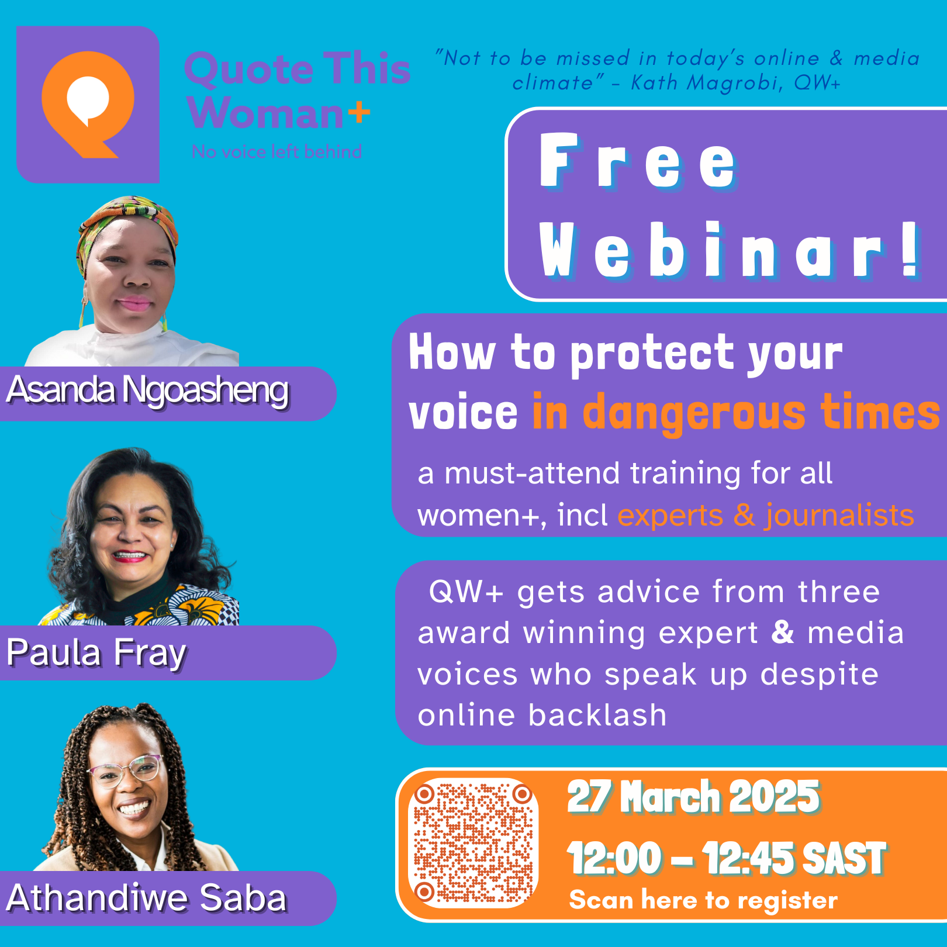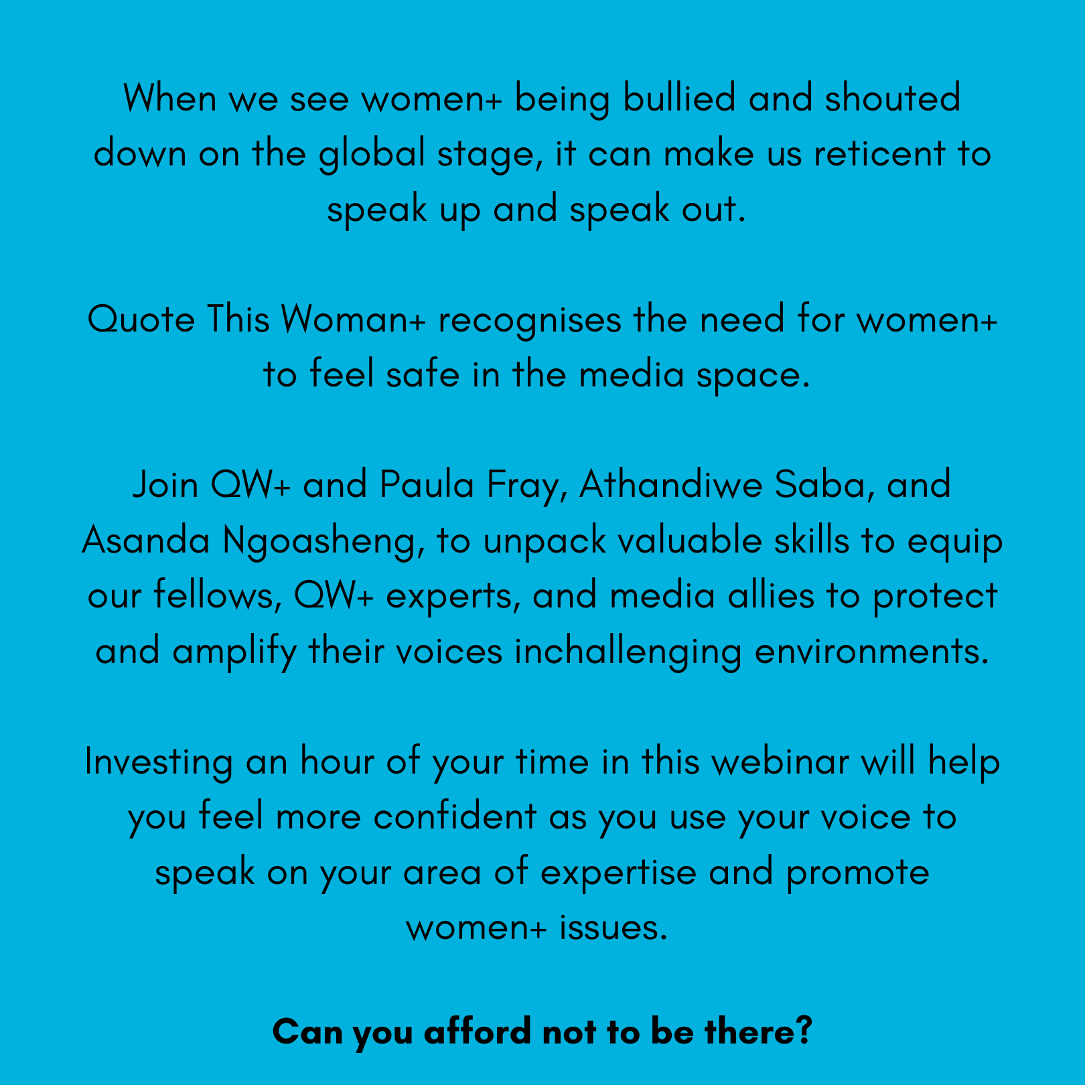

Additional sources:

<http://unwomen.org/en/articles/faqs/digital-abuse-trolling-stalking-and-other-forms-of-technology-facilitated-violence-against-women#:~:text=Other%20forms%20of%20abuse%20that,sharing%2C%20sextortion%2C%20revenge%20porn>.

[a-79-500-sg-report-ending-violence-against-women-and-girls-2024-infographic-and-recommendations-en.pdf](https://www.unwomen.org/sites/default/files/2024-10/a-79-500-sg-report-ending-violence-against-women-and-girls-2024-infographic-and-recommendations-en.pdf)